**Project Title**: **COOKBOOK**

**Team ID**: NM2025TMID39844

**Leader Team**: NITHIYA SRI R

**EMAIL ID:**[nithiyasrirvrph@gmail.com](mailto:nithiyasrirvrph@gmail.com)

**TEAM MEMBERS**:

JASMINE G

**EMAIL ID:**[jasminegopi2007@gamil.com](mailto:jasminegopi2007@gamil.com)

JAYASRI J

**EMAIL ID**:[jayasritwinkle06@gmail.com](mailto:jayasritwinkle06@gmail.com)

KALAISELVI M

**EMAIL ID**:[mkalaiselvi314@gmail.com](mailto:mkalaiselvi314@gmail.com)

**COOK BOOK**

**1.INTRODUCTION**:

This project is designed to be a virtual assistant for the kitchen.as an “active” project on the smart intern platform, its likely a hands-on assignment for students to develop a web or mobile application that helps users with cooking.

This project aims to make cooking easier for beginners and enjoyable for experienced chefs by serving as a personal digital recipe book.

**2. PROJECT OVERVIEW**

**Purpose**: The purpose of this cookbook project is to learn how to research, document, and present culinary information. Also to preserve traditional recipes and pass them on to future generations, while also celebrating the culture and memories connected with food.

**Features:**

* Tested and clear recipes
* Headnotes
* Ingredient and Equipment lists
* Logical Organization
* Helpful Guides

**3. ARCHITECTURE**

* **FRONTEND**: a modular, component-based frontend architecture with reusable UI (recipe cards, filters, search), center state management, and service-based API integration for scalable cookbook features.
* **BACKEND**: a layered backend architecture with API controllers, service layer for business logic, data access layer for recipes and users, and database integration for scalable cookbook management.
* **DATABASE:** A relational database architecture with tables for recipes, ingredients, categories, users, and favorites linked through normalized relationships for efficient cookbook data management

**4. SETUP INSTRUCTIONS**

* Prerequisites:
  + Node.js and npm
  + React.js
  + HTML, CSS and JavaScript
  + Version Control

**Installation Steps:**

* Set up database
* Install backend
* Install frontend
* Configure system

**5.FOLDER STRUCTURE**

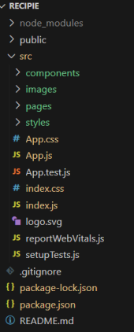 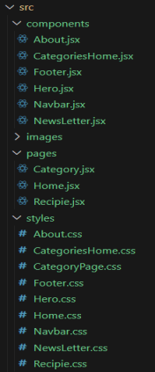

**6.RUNNING THE APPLICATION**

* **Frontend:**

Cd cookbook-frontend

Cd client

npm start

* **BACKEND**

Cd cookbook-backend

Cd server

npm start

ACCESS: VISIT http://localhost:3000

**7.API DOCUMENTATION**

**User:**

POST/api/user/register- Register new user

POST/api/user/login-login user

**Recipes:**

POST/api/recipes/create-create all recipes

GET/api/recipes-get all recipes

GET/api/recipes/:id-get recipe details

PUT/api/recipes/:id-update recipe

DELETE/ api/recipes/:id

**Reviews:**

* /api/reviews/add
* /api/reviews/: recipe id

**8.AUTHENTICATION**

The project uses a JWT (JSON web token) based authentication system.

This approach provides a secure way for users to log in.

The system also uses middleware to protect private routes, ensuring that only authenticated users can access specific pages or features.

**9.USER INTERFACE**

**The** user interface is composed of several key pages:

* **LANDING PAGE**: The main entry point for the application.
* **DASHBOARD FREELANCER**: A dedicated dashboard for users categorized as freelancer. This is likely where they will manage their profiles and projects.
* **ADMIN PANEL**: A restricted area for administrators to manage the application, users, and content.
* **PROJECT DETAILS PAGE**: A page that displays detailed information about a specific project.

**10.TESTING**

The project ‘s quality assurance process involves manual testing at various stages of development. The team uses standard tools like postman for API testing and chrome dev tools for debugging and front -end development.

**11.SCREENSHOT**

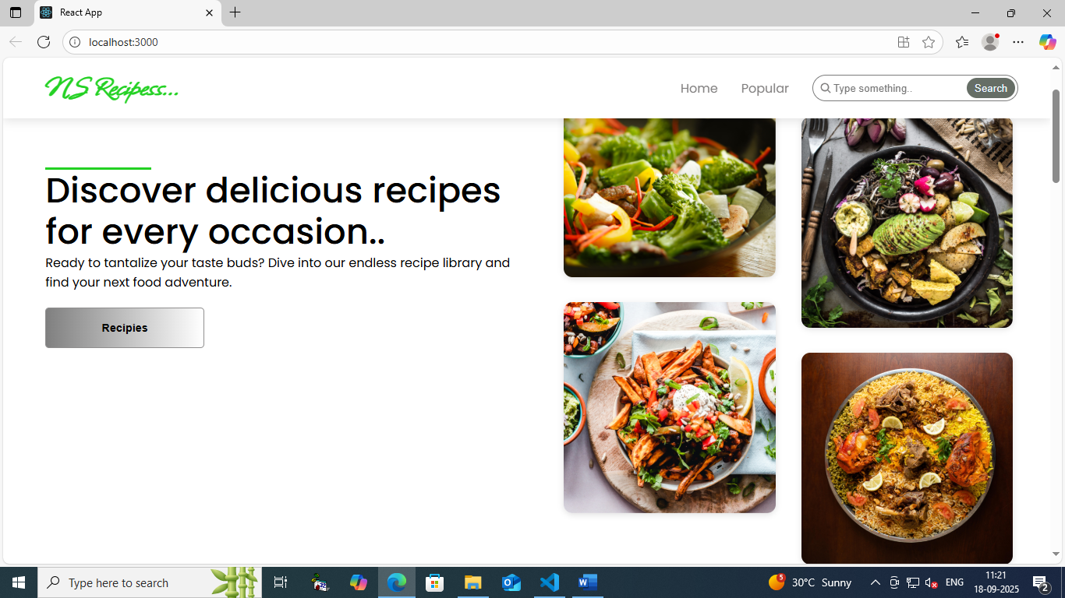

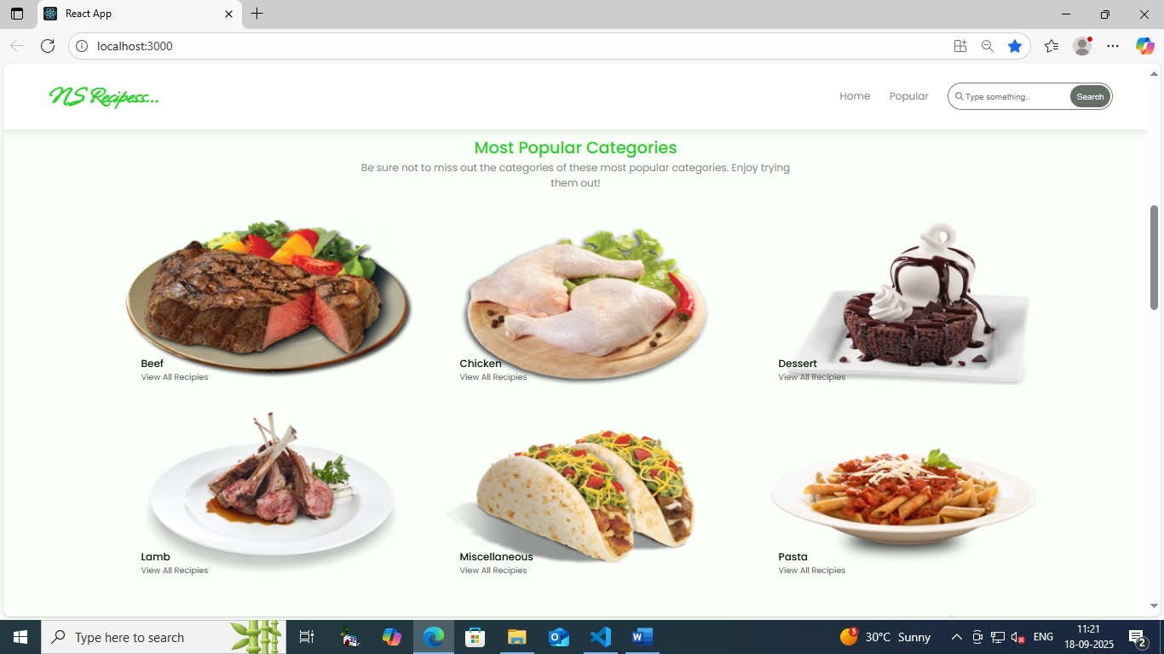

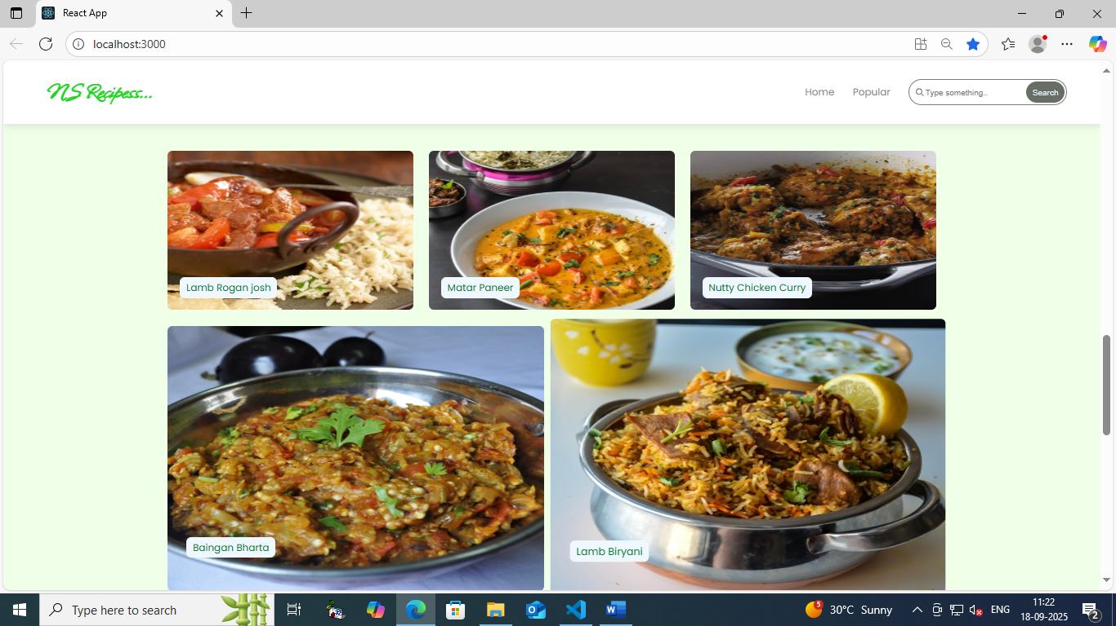

**12.KNOWN ISSUES**

**1.IMAGE LOADING ERRORS**

* Some step-by-step pictures may not appear in the e-book version.
* Fix: Try a different device or update the reader app

**2.OR CODES NOT WORKING**

* Scannable links to videos might lead to dead pages
* Fix: Check the publisher’s website for update links

**3. Measurement confusion**

* Recipes may mix metric (grams/ml) and imperial(cups/oz)without clarification
* Fix: Use a reliable conversion chart

1. **Inconsistent Cooking Times**

* Visual assistant shows shorter/longer times than written instructions.
* Fix: Always reply on doneness cues

**5.App integration problems**

* If paired with a companion app, it may crash, freeze, or not support new devices

**13.FUTURE ENHANCEMENT**

• **AR Integration**: 3D models and step-by-step guidance in your kitchen.

• **AI Personalization**: Custom recipes based on preferences, dietary needs, and cooking skill.

• **Ingredient Substitutes**: Real-time suggestions and shelf-life tracking.

• **Voice Control**: Hands-free cooking and meal planning with voice assistants.

• **Smart Appliances**: Sync with kitchen tech for automatic adjustments and feedback.

• **Video Tutorials**: Step-by-step cooking videos, with motion capture for technique feedback.

• **Collaborative Cooking**: Multi-user features for shared meal planning and cooking sessions.

• **Smart Grocery Lists**: Auto-generated shopping lists and online ordering